AWS Elastic Bean Stalk

On demand resource provisioning

Peak load and low load provision of resource as when needed

Step 1: create an application

Step 2: create different env

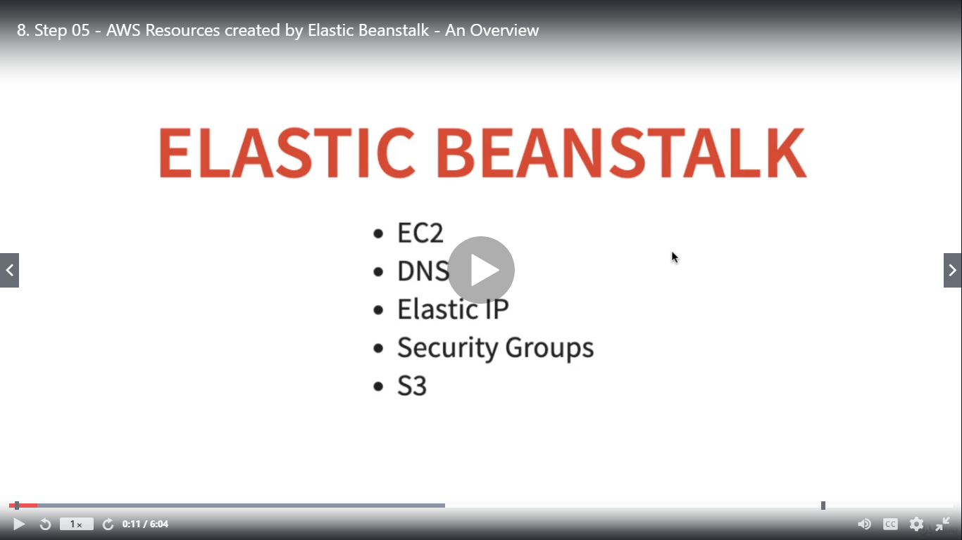

S3 store version of jars & wars

Apache http server act as reverse server in war, nginx